**Experiment No :** 02

**Name of the Experiment :** ­­Verification of Ohm’s Law.

**Objective:**

* To verify Ohm's Law by measuring the relationship between voltage, current, and resistance in a simple electrical circuit.
* To determine the resistance of a resistor using experimental voltage and current measurements.
* To gain practical experience in using electrical measuring instruments such as voltmeters and ammeters to measure voltage and current in a circuit.

**Theory:**

Ohm's Law is a fundamental principle in electrical circuit analysis that defines the relationship between voltage (V), current (I), and resistance (R) in a conductor. It states that the current flowing through a conductor is directly proportional to the voltage applied across it and inversely proportional to its resistance, provided the physical conditions (such as temperature) remain constant.

The mathematical expression for Ohm's Law is:

$$V = I × R$$

Where:

* V is the voltage across the conductor (measured in volts, V).
* A is the current flowing through the conductor (measured in amperes, A)
* R is the resistance of the conductor (measured in ohms, Ω)

**Apparatus:**

* Voltmeter ( 1 piece; 0-450 V )
* Resistance ( 1 pieces; 108Ω )
* AC voltage source (220V, 50Hz)
* Connecting wires
* VARIAC

**Circuit Diagram:**

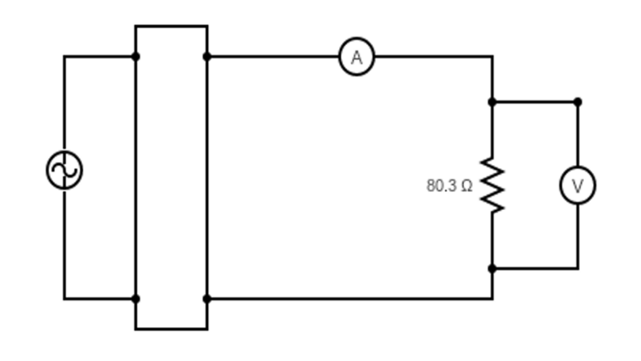

106.3 Ω

V

A  
R  
I  
A  
C

Figure-01: Electric Circuit

**Data Table:**

|  |  |  |  |  |  |
| --- | --- | --- | --- | --- | --- |
| **SL no.** | **Resistance**  **(Ω)** | **Voltage**  **(V)** | **Current (A)** | **Calculated Resistance (R)** | **Error** |
| 1 | 106.3 | 49.5 | 0.46 | 107.60 | 1.2% |
| 2 | 60 | 0.56 | 107.14 | 0.79% |
| 3 | 69.5 | 0.65 | 106.92 | 0.58% |
| 4 | 80.4 | 0.76 | 105.79 | 0.48% |
| 5 | 90.3 | 0.85 | 106.23 | 0.07% |

**Graph:**

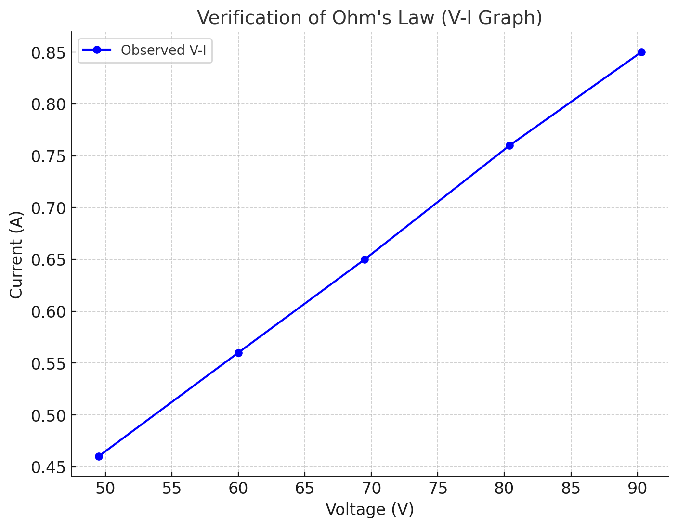

**Result:**

The experimental verification of Ohm’s Law demonstrated a consistent relationship between voltage (V), current (I), and resistance (R). For the given circuit, the calculated resistances closely matched the theoretical resistance of 106.3 Ω across different voltage and current readings. The observed errors in calculated resistance were minimal, ranging from 0.07% to 1.2%. These small discrepancies can be attributed to instrumental limitations, slight variations in the resistor's actual value, or environmental factors such as temperature. The results confirm the validity of Ohm's Law, as the resistance values remain nearly constant, verifying the linear relationship between voltage and current within the circuit.

**Conclusion:**

The experimental results successfully verify Ohm’s Law, demonstrating a consistent relationship between voltage, current, and resistance. The observed errors were minimal, indicating high experimental accuracy. These minor discrepancies are likely due to instrumental limitations or environmental factors. Overall, the results confirm the validity of Ohm’s Law, reaffirming its reliability in analyzing the behavior of electrical circuits. The linear relationship between voltage and current observed in the experiment supports the fundamental principles of electrical resistance.